The Norfolk Area Chamber of Commerce Ag Council and the Madison Area Chamber of Commerce Co-Host:
The Northeast Nebraska Ag Banquet
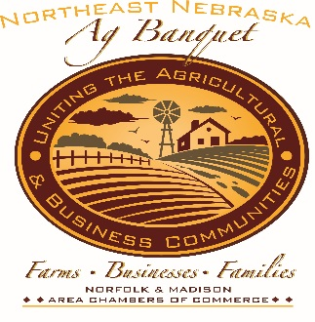

June 18, 2020 at the Madison County Fairgrounds
Speaker: TBA

Award Nomination Information for
Farm Family of the Year -or- Ag-Business of the Year

We are asking that you nominate worthy candidates for the Farm Family of the Year Award and the Agribusiness of the Year Award to be presented at the banquet.

Guide to Nominating
Depending on the award, the nominee should exhibit some or all of these characteristics:

- Produce or have a business in Madison, Antelope, Pierce, Wayne, Stanton, Boone or Northern Platte counties

- Be an established company, family, or individual with a record of community service and/or stimulation of the Northeast Nebraska economy through agriculture or related activities

- Have made a significant contribution to the agriculture industry such as:
  - Producers who have been actively involved in state-wide agricultural organizations and provided leadership in a variety of ways

DEADLINE FOR NOMINATIONS: JUNE 1, 2020

Return form to 609 W. Norfolk Ave, Norfolk, NE 68701 Contact Jeny at 371-4862 for more information.

Norfolk Area Chamber of Commerce 609 W. Norfolk Ave
Norfolk, NE 68701
P (402) 371-4862
F (402) 371-0182

Madison Area Chamber of Commerce
209 S. Lincoln
Madison, NE 68748
P (402) 454-2251
F (402) 454-2262

Award Nomination Form 2020
Farm Family of the Year
Ag-Business of the Year

Nominee:
Company Name (if applicable)
Type of Business
First Name
Last Name
Address
City, State Zip
Phone Number
Company Phone Number
E-mail Address

Nominator:
Company Name (if applicable)
First Name
Last Name
Address
City, State Zip
Phone Number
Relationship to Nominee
E-mail Address

Questions on the next page. Please complete the items to the extent you can without contacting the nominee.

Award Nomination Form 2020
(continued)

Complete these items to the extent you can without contacting the nominee.

Please provide a summary of contributions to Northeast Nebraska and Nebraska Agriculture in regard to production agriculture, agri-business or other agricultural organizations:

Honors or Recognitions:

Other pertinent information:

Please attach additional sheets if more space is needed.

Signature: Date:

